# Project Overview Pija 피자 (Pizza) Clothing

## Online Clothing Store - AMES CS103 Project

## William Doctor & Reuben McDonald

[https://trello.com/b/x9S23Aqq/pija-project?menu=filter&filter=Don](https://trello.com/b/x9S23Aqq/pija-project?menu=filter&filter=Don" \t "_blank)

[https://app.smartsheet.com/b/home](https://app.smartsheet.com/b/home" \t "_blank) Gantt chart

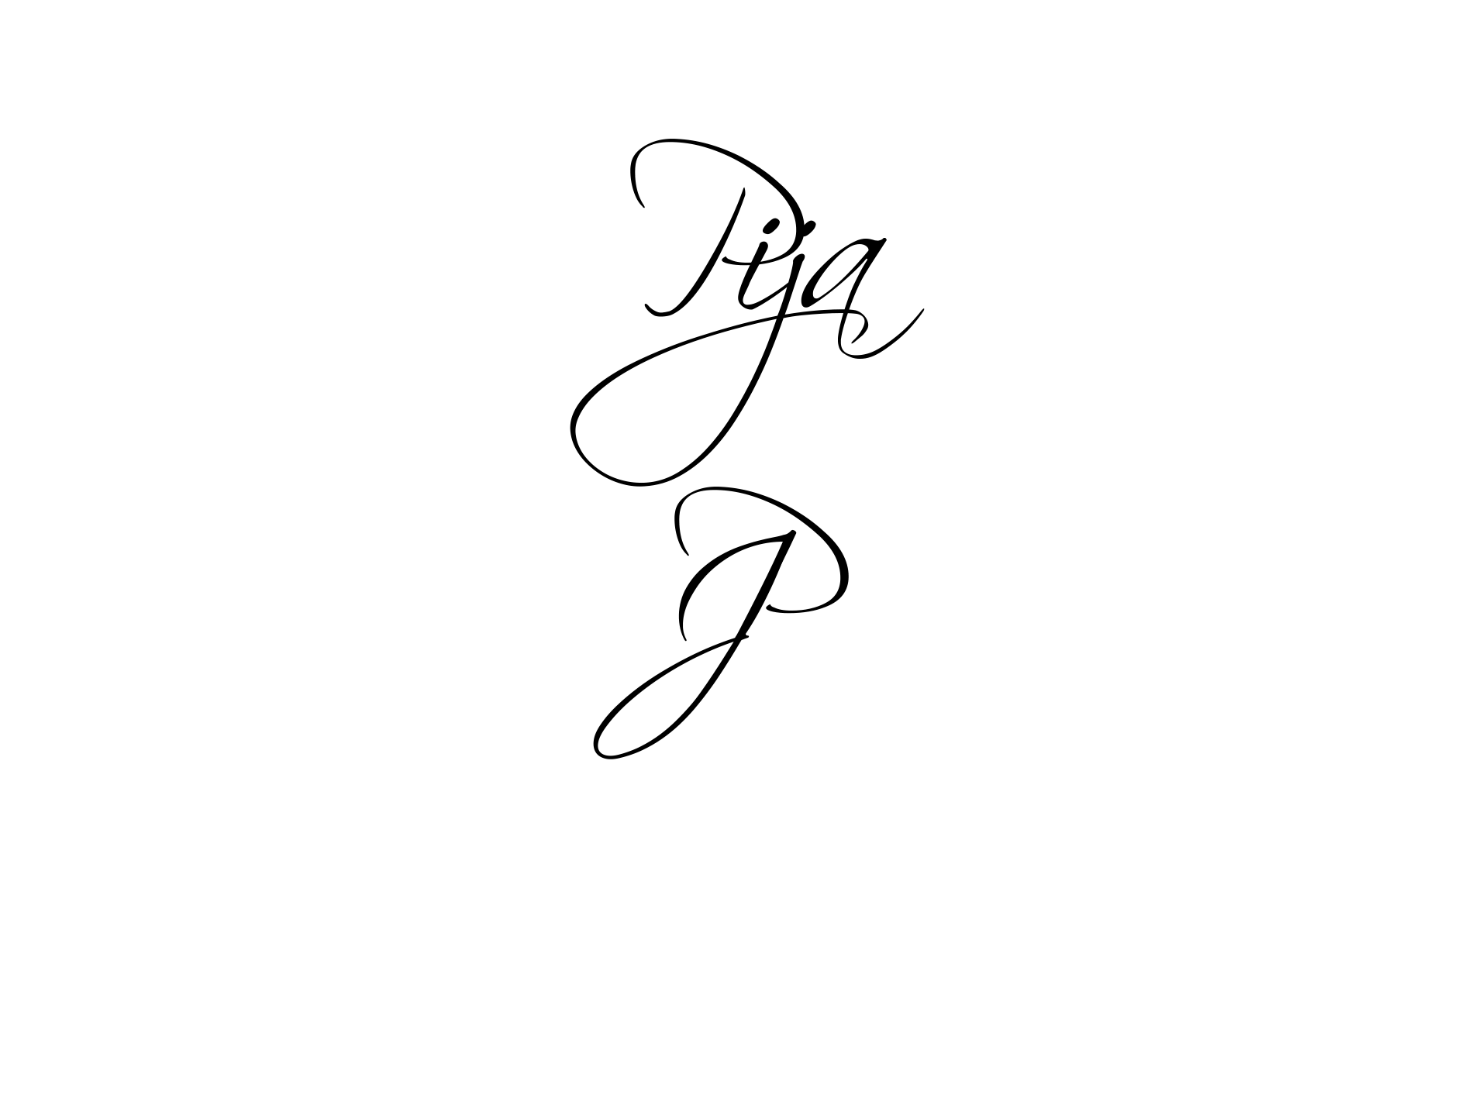

# Project Overview

The purpose of this website is to expend our target audience, and to be able to see if our product (Clothing brand) will be successful as like high brands like (Nike, Adidas, Gucci and etc), able to see if our product will be viewed and purchased on a worldwide. Pija is a Clothing brand that We created, we made Pija as a Clothing brand because we want to be a global clothing online store that everyone will like or enjoy our clothing brand. Pija means pizza in Korean 피자. We named it Pija because We did an assessment that was related to this project did a Drama website called KissAsian. We wanted a new website because we wanted to see our popularity of the product, with the new website.

Pija is a online store, can be shipped global, we think that our Clothing store will start low because not that many people will know about Pija Clothing, but when we create a website and do advertisement, Pija clothing popularity will increase because every teenagers, young adults are on social media most of the time, they will see ads, they will see a new clothing brand and the views on our website will sky rocket slowly at first but faster when people fined out quality clothes with a mid-range price tag. When people are looking at our Clothing for the first time, its important to have a positive impression, people judge the clothing through the website and the clothes through the website. They check if our website is professional and legit, not a scam website as the website will look professional.

If we get a positive impression, people around the world will see our brand, people will see other people wearing Pija clothing and be interest in the product, people will research our product when and where you will be able to collect our clothing. Pija clothing will scale well global, if we manage our website well, our marketing will only increase and more fans will want more design.

We will deliver a website that fulfills the needs of the target audience, nicely UI (User Interface), our website will be easy to navigate, and a UX (User Experience). we want to impression our target audience with our website, something unique and different to other clothing website online. want our website to get peoples eyes and hook on to our clothing brand. simple but tidy and unique. a website that we can compare this prospective to is [http://www.supremenewyork.com/shop](http://www.supremenewyork.com/shop" \t "_blank), [http://www.hm.com/nz](http://www.hm.com/nz" \t "_blank) or [https://www.gucci.com/int/en/](https://www.gucci.com/int/en/" \t "_blank) so that we can have a verity of clothing websites that give us wide range of ideas and designs for the website so that we can create a website can look professional as Gucci but has the vibe of a company that looks after it’s customers with good quality products that is reflected both on the website and the company.

# Business Need

The website will improve sales though marketing, sales through the website and through advertising the website as you didn’t have a website before this will open a new door of revenue as the knowledge o your store will expand at a faster rate as when the company is mentioned the first place someone will look is online.

Regarding the project scope: The end project will be a professional website that opens doors to other marketing areas that were left untapped to this small company than with out the having a website because the website increase amount of people that can see the range of products that the company sells will increase.

Functionality: the key aspects that the website can do for the users is show where the stores are, show them the collections that the company makes, show when sales are so that users don’t have to go to the stores with a wasted trip so the website can tell when the sales are on and when they finish.

# Specification (deliverable’s):

* Carousel for showing clothing and sales
* Drop-down navigation.
* Data base containing stock - sold and not sold.
* Horizontal navigation bar.
* Search bar.
* Top button (when pressed will go to the top of the page).
* Login/ Logout data base of users.
* Store locator if user wants to try the products out before buying any clothing.
* Sort - Newest, Cheapest.

# Audience and Stakeholders

Our target audience are mostly for teenagers and young adults, they are most likely to be wearing our clothing brand, i believe they will enjoy and love our clothing brand because its new and different to other clothing brands like Gucci, Supreme, and etc. The target audience will be able to access our website through Mobile and Desktop, most people are usually on there phone through out the day, looking through social media so most likely they will see on their phone and they could research the product on their desktop to get more information or they could find it on social media like on Facebook, Instagram, Twitter and etc. PiaDesai will be sponsoring our website, clothing brand Pija Clothing. she will be helping our product to release. We decided to pick Pia because our clothing brand Pija is similar to her name Pia, and its like promoting herself and our clothing brand together, shes like wearing her own clothing that saying her name on it. She agreed to sponsor our clothing brand Pija Clothing brand will be on e-commerce, services online over the internet, they will be able to buy our clothing brand through our website. we decided to make it our clothing brand online because Most high clothing brand are mostly sold online and most likely to be successful product, its different to other clothing stores like Cotton On, Hallensteins, Factorie and etc. it will be more easy to get more research online then reading a brohure or catalog. online you will be able to track your product where about it is and see the estimate date when its coming.

# Agile User Story

As a   (type of user), I want (some goal) so that (some reason).

|  |  |  |  |
| --- | --- | --- | --- |
| User Story ID | As a (type of user) | I want to (preform a task) | so that I can (achieve some goal) |
| 1 | End user | buy clothes that are in my budget | buy clothes at home |
| 2 | End user | look at the catalog | buy them at home |
| 3 | End user | know when their are sales on | go to the stores and try out the clothes that are on for sale |
| 4 (Sponsers) | Sponsor (Pia) | Provide help | create capital from my invesment |

End user

I want a online store that sets a max  price for clothing so that I can see what clothes i can buy for that amount of money.

End user

I want  the company Pija to have online store so that I can buy clothes from the comfort of home.

End user

 I want to know when their are sales so that I can go to the stores and try out the clothes that are on sale instead of making a wasted trip to the mall see if their are sale’s at the moment.

Pia - Sponsor

I want a working website that provides all of the needs for the users so that the company Pija grows and creates capital so that I get my investment back and gain capital.

Reuben - Team Leader

I want the website (Pija) to be easily navigated to that users have no trouble getting to where they want to go. Also want the data base to easy fro the users to use so they can shop easily with the listed Items that they want in their shopping basket.

William - Lead collaborator

I want to have clothes that customers want to buy and to have a website that make it easy for them to buy products from the Pija website. Also I want costumers to have a good look at what their buying with pictures of front and back of products so they can see what the product looks like.